Arrowhead System Description (SysD) – Translation System

**Abstract**

The translation system provides an Arrowhead local cloud with protocol translation capabilities. It provides the translation service and hosts the transient translation end-points. It is intended to be run on server machines or embedded intelligent gateways such as a BeagleBone black.

Table of Contents

Table of Contents 2

1. System Description Overview 3

2. Use-cases 3

3. Diagrams 3

4. Application services 3

4.1. Produced Services 3

4.2. Consumed Services 3

5. Security 3

6. References 3

7. Revision history 3

7.1. Amendments 3

7.2. Quality Assurance 3

1. System Description Overview

The Translation system operates within a local cloud. It provides the translation service. The translation service receives requests for protocol translation between a pair of service provider and consumer. Protocol conversion is supported between HTTP, CoAP and MQTT at the moment. Outstanding would be to get OPC-UA and XMPP added as protocols for translation.

1. Use-cases

The translation system is used in two ways. One is a management and control use case which is responsible for generating new translators. And the second use case is the interaction between the protocols. The second use case is very dynamic as it is dependent on the service and the protocols being translated.

Table 1 Translation Request use case description

|  |
| --- |
| **Translation Request** |
| **ID**: 0001 |
| **Brief description**:  In this use case the translation system will receive a request for translation, will create the translation end-points and return these to the consumer. |
| **Primary actors**:  Orchestrator is the primary user |
| **Secondary actors**:  The end points which will interact with the new transient translator. |
| **Preconditions**:  The Translation system is registered with the Arrowhead service registry. |
| **Main flow**:  Present in a sequence of steps the interactions among the actors   1. Consumer send request for translation, providing require info (see service description) 2. Translation system parses request and sets up protocol end points, pointing one at the target service provider 3. Translation system responds with the address of the protocol awaiting the service consumer invocation. |
| **Postconditions**:  The translator must have open protocol spokes for translation. |
| **Alternative flows**:  If there is problem in the request:   1. Translation system responds with an error   If the spoke is not supported:   1. Translation system responds with an error |

1. Diagrams

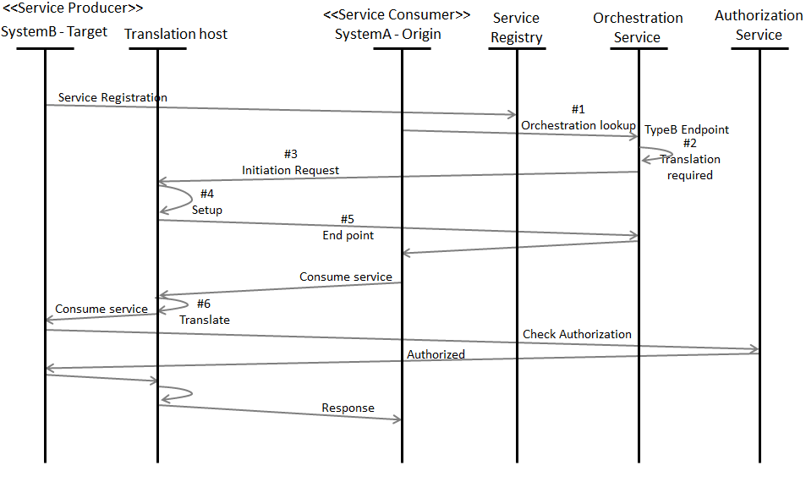

1. Application services

This section contains the Produced and Consumed services. The description should be in different sub-sections. Every service contains on its description pointer to the IDD document.

# Produced Services

Table 2 Pointers to IDD documents

|  |  |
| --- | --- |
| **Service** | **IDD Document Reference** |
| Translation Service | Arrowhead IDD Translation Service.doc |

A description of the provided services should also be included.

# Consumed Services

Table 3 Pointers to IDD documents

|  |  |
| --- | --- |
| **Service** | **IDD Document Reference** |
| Service Discovery | Arrowhead_IDD_Service Discovery REST_WS-XML-SPSDTR.pdf |
| Authorisation Control | Arrowhead_IDD_Authorisation Control REST_WS-TLS-XML-SPAUTH.pdf |

A description of the consumed services should be included.

1. Security

Currently, the translator does not support security, however will support Arrowhead security. TLS and DTLS will be supported in the future.

# Security Objectives

# Assets

# Non-technical Security Requirements

1. References

Any references must be placed here.

1. Revision history

# Amendments

|  |  |  |  |  |
| --- | --- | --- | --- | --- |
| No. | Date | Version | Subject of Amendments | Author |
| 1 | 2013-12-03 | 0.2 | Revisions | Christos Chrysoulas |
| 2 | 2013-12-18 | 0.3 | Text Revisions | Christos Chrysoulas |
| 3 | 2013-12-24 | 0.4 | Added quickparts and saved as template | Ove Jansson |

# Quality Assurance

|  |  |  |  |
| --- | --- | --- | --- |
| No. | Date | Version | Approved by |
| 1 |  |  |  |
| 2 |  |  |  |